EXPERIMENT-5

AIM: TO WRITE SQL QUERIES TO PERFORM SPECIAL OPERATIONS(i.e

LIKE,BETWEEN,ISNULL,ISNOTNULL)

**Creating a table**

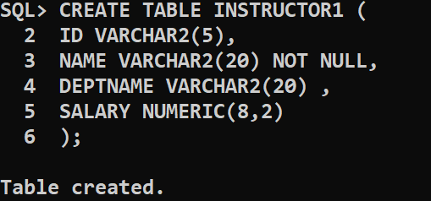

**Inserting values into first table:**

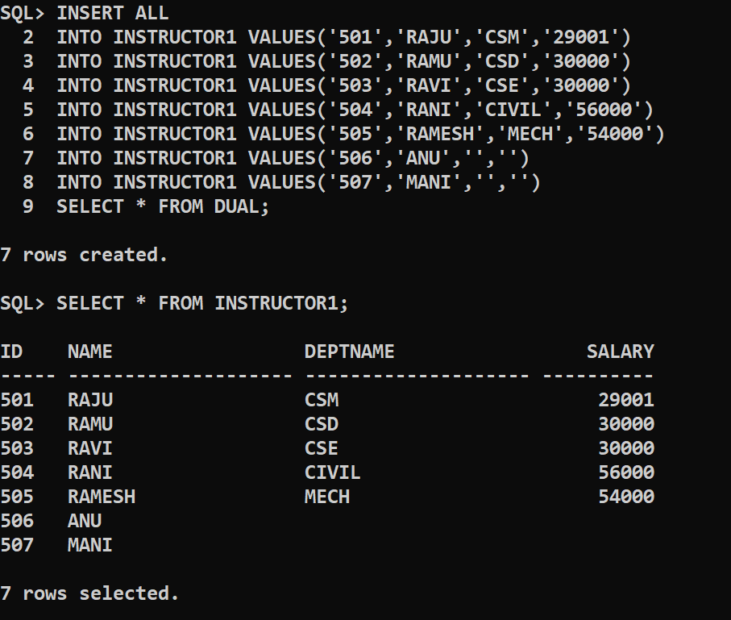

**Is Null operation :**

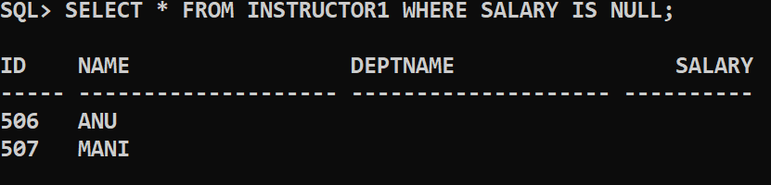

Lies between given value :

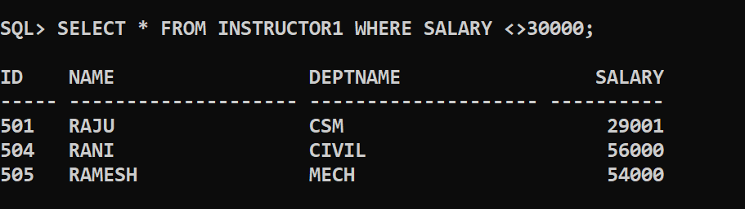

**Is not null operation :**

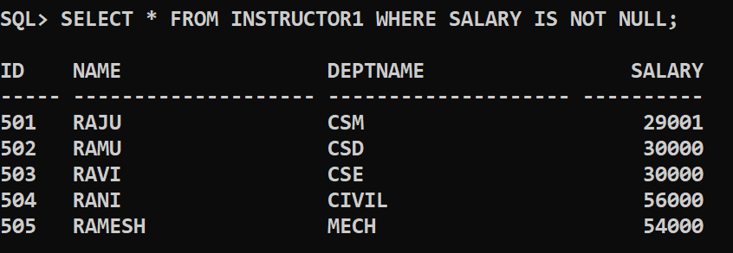

**Between operation :**

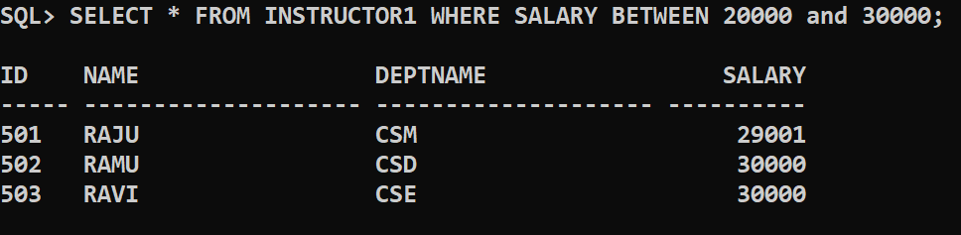

Not between operation :

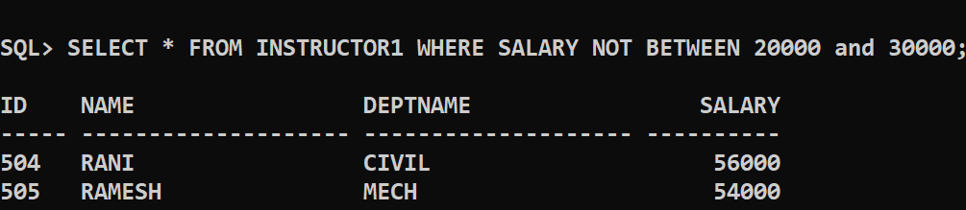

**Like operation:**

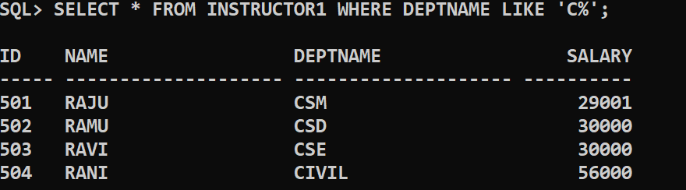

**Exists operation :**

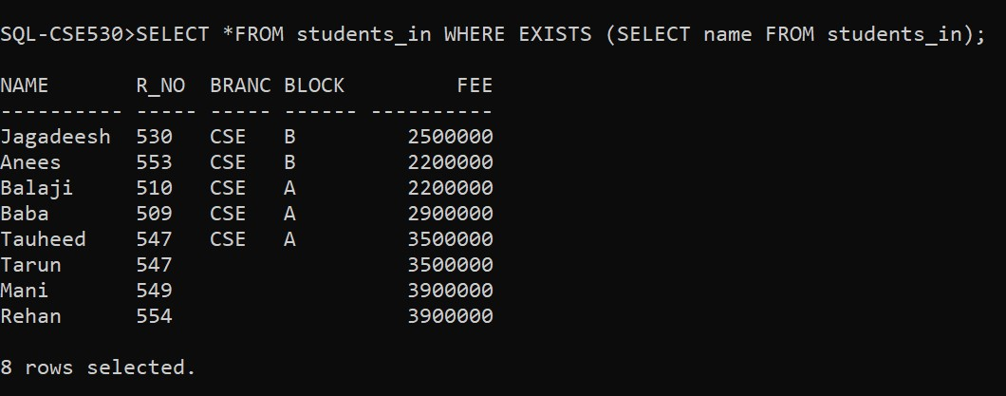

**Conclusion : The sql queries to perform special operations are successfully executed.**